|  |
| --- |
| Circle Language Spec: Commands |

## Executables & Executions in a Diagram

The concept of executables and executions has already been explained in the article *Executables & Executions*. The current article demonstrates the concept using diagrams.

An executable object stands for a potential execution:

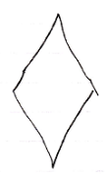

An executable object never stands for multiple executions, just one exectution or no execution at all.

The same command object can be displayed in the diagram multiple times. In that case, automatic containment will add a symbol to the diagram, that the multiple references to the same command object will converge to, so that a single symbol in the diagram is selected to represent the command object itself, while the other ones are just references.

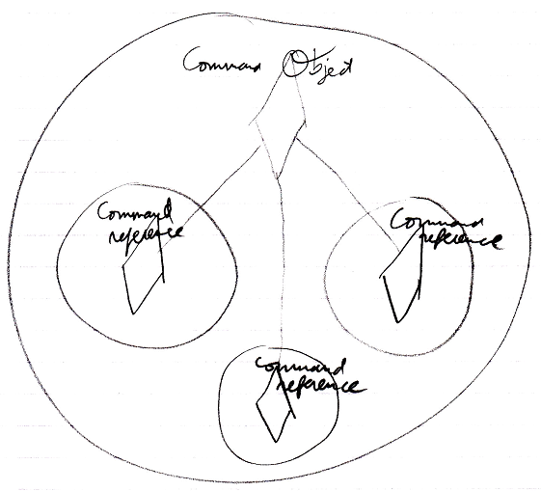

So it is not so, that each diamond in the diagram represents its own individual command execution. Each individual *command object* represents an individual command execution. Multiple symbols in the diagram can represent the same command object, but will converge into one symbol representing the object itself.